

**GRAPHICS AND ANIMATION TOOLS**

**SEMESTER: VII**

**PROJECT REPORT**

**DECEMBER 2020**

**ABOUT:** In this project I have designed an interior model of a living room with a little dark ambience and basic furniture’s like a table, sofa and TV with slightly dark lighting. For this I have used IsoCam addon to add a camera view to the scene and images as planes to add the painting to wall. The base wall is colored white to reflect light off it. The planes are extruded to give a wall like effect to it. It has following furniture and objects:

* Sofa
* Television
* Bottom Rack
* Table
* Painting
* Floor
* Books

**STEPS:**

1. **SOFA:**

* Add a plane
* Extrude it to a set height
* Add 3 loop cuts on 3 sides .5 inches from sides.
* Extrude the loop faces further up
* For cushion take a plane and extrude it upwards.
* Create 4 loop cuts near 4 corners of the cushion.
* Inset the 4 small faces and extrude and bevel them inwards to give the cushion a denty look.
* Finally Use smooth shading and subdivision modifier and smooth shading to finalize the sofa and use black color with minimum roughness.

1. **Television:**

* Add a plane
* Inset and extrude it.
* Bevel and Extrude the back face slightly inwards to give a small bump on the back.
* On the plane on the shader tab add an image to the base color to add an image to television
* Color the Television Black with shining to create the final texture for TV.

1. **Bottom Rack:**

* Add a plane
* Extrude it
* Inset the front face and Intrude it inwards to create a hole in centre.
* Download and add a wooden texture to the base color node to shade the rack.

1. **Table :**

* Add a cube and thin it on z axis and increase its length on x axis to create base of table.
* Add 4 cylinders
* Thin down the cylinders on z axis and elongate it on y axis to create the leg of table
* Do the same for all 4 legs.
* Use G button to place the legs just below the table.
* Go to shader and add the desired texture node to base color node in the entire table.

1. **Painting:**

* Make sure to enable Images as faces addon in the addon menu.
* Add a plane on a wall
* File-import images as planes.
* Place the image appropriately.
* Extrude it just slightly.

1. **Floor:**

* Tab- go to edit mode
* On the floor plane open the shader tab
* Add the desired texture node and attach it to the base color of floor.

1. **Lighting:**

* 3 lighting are used in the following 3D model.
* One is places on the upper corner to give the room a basic light.
* The other two are placed on two other locations to give the room the feel of a residual light coming from other place and to create a dark and cool ambience.

**RENDERED IMAGES:**

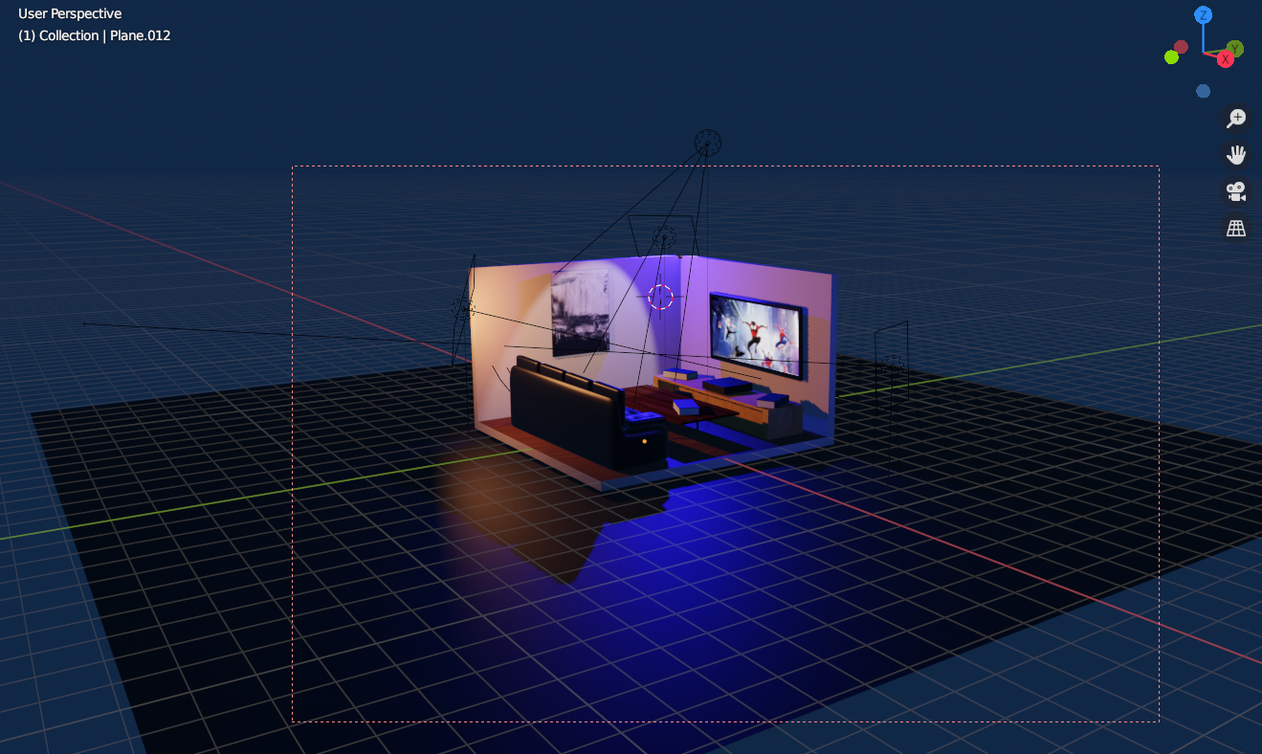

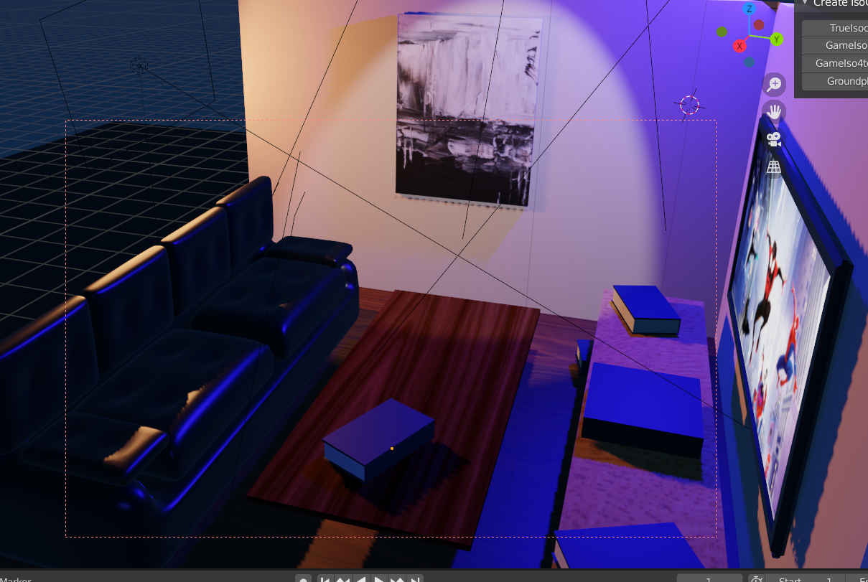

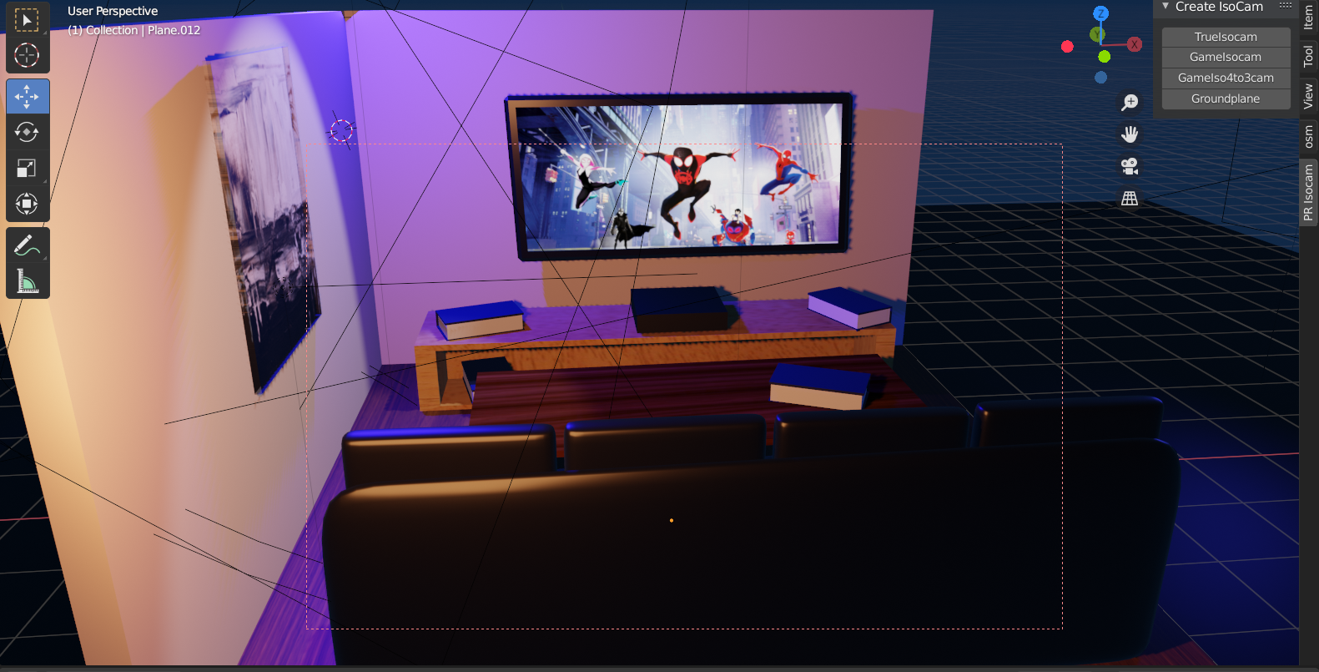

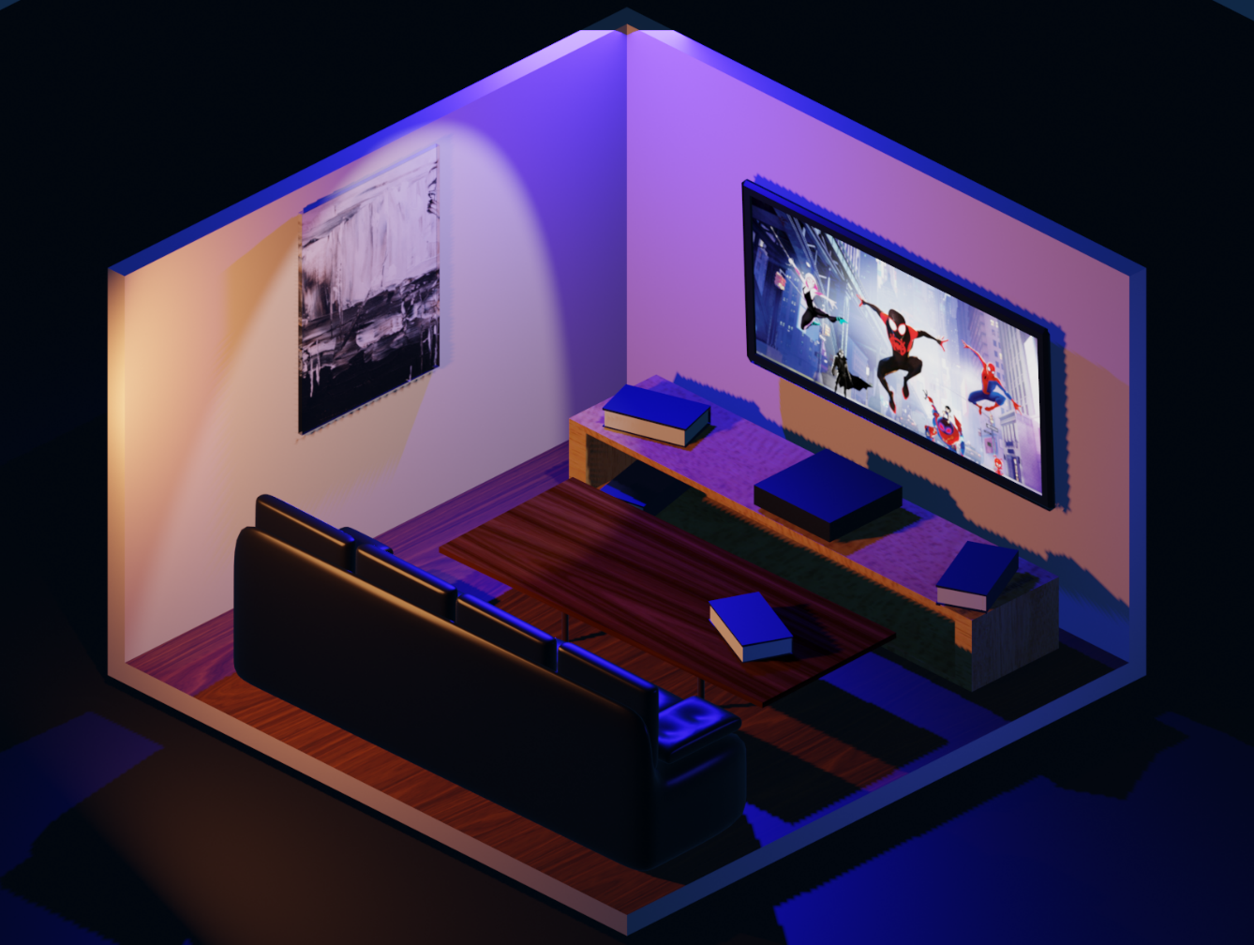

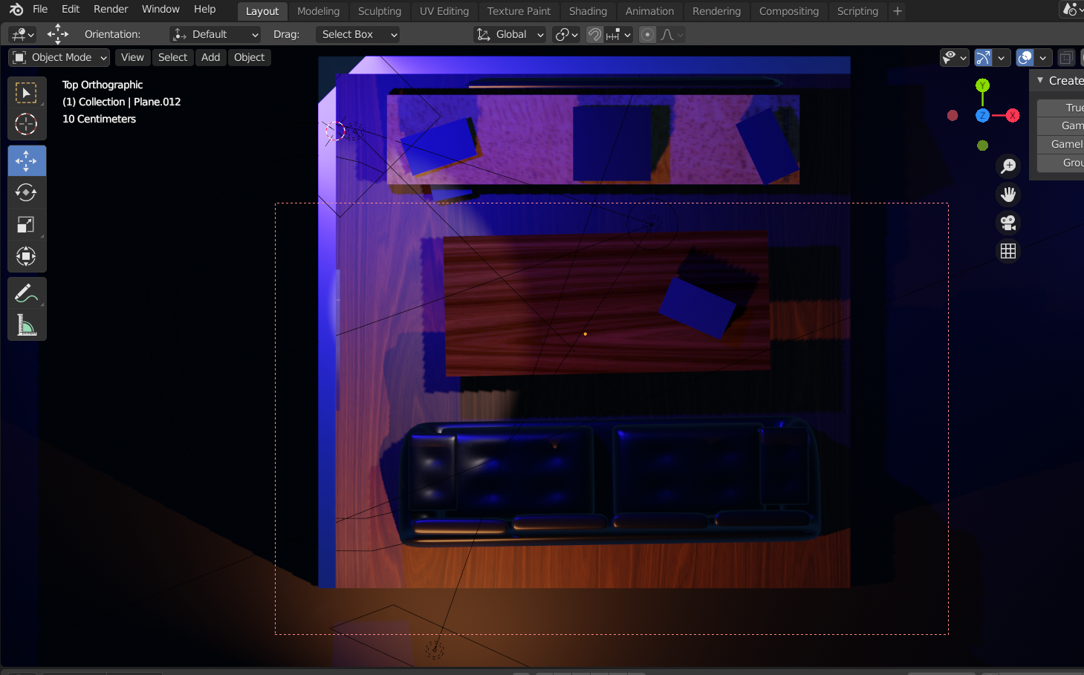

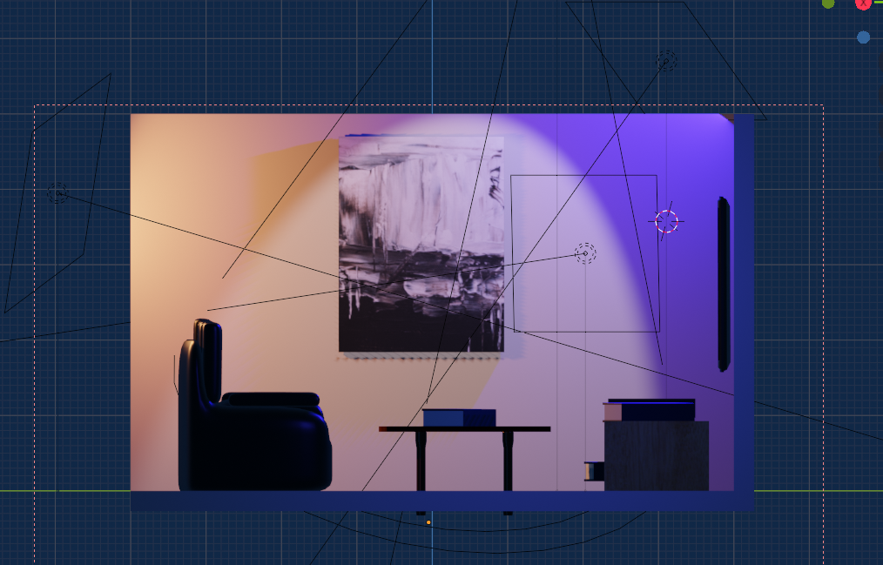

**SUBMITTED BY:**

***SATVIK NIGAM***

***R100217105***

***500063880***